Week 5 Readings
Complete the following readings early in the week:
- Read the Week 5 and 6 Online Lecture.
- Read pages 48-55 from the textbook, Peck's Atlas of Human Anatomy for the Artist.
- Read pages 56, 98-99 and Chapter 8 pages 112-121 from the textbook, Basic Figure Drawing, by Greg Albert.
- Read pages 122-127 from the textbook, Peck's Atlas of Human Anatomy for the Artist.
- Read pages 78-85 from the textbook, Peck's Atlas of Human Anatomy for the Artist and, pages 54-55, 94-95 from the textbook, Basic Figure Drawing Techniques by Greg Albert.
- Read pages 138-143 from the textbook, Peck's Atlas of Human Anatomy for the Artist.
- Read Chapter 7 pages 101-111 from the textbook Basic Figure Drawing Techniques by Greg Albert, and pages 10-21 from Peck's Atlas of Human Anatomy for the Artist.
- Read pages 91-101 from the textbook, Peck's Atlas of Human Anatomy for the Artist.
- Read page 196 from the textbook, Peck's Atlas of Human Anatomy for the Artist.
Week 5 Assignments Overview
Assignment Summary: Week 5 | Due Date
Assignment 1: Hands and Feet Life Drawing | Wednesday, August 13, 2008
Assignment 2: The Skull/Head/Neck Life Drawing | Thursday, August 14, 2008
Assignment 3: Rough Draft Full Self-Portrait, Standing or Seated | Saturday, August 16, 2008
Remember that all Assignment details can be found on the assignment pages located throughout the week. Go to those specific pages for direction on how to complete each individual assignment.

Assignment 1: Standing Poses - Life Drawing Session
- By Tuesday, August 5, 2008, draw 8 stick figures in several variations of the three basic types of standing poses (see lecture Standing Poses Life Drawing Session).
- Conduct your first life drawing standing pose session. Time yourself and create standing pose drawings of your model or yourself. To do your half-hour "warm-up" do the following sequence:
  - Draw 2, 1-minute poses.
  - Draw 2, 2-minute poses.
  - Draw 2, 3-minute poses.
  - Draw 2, 5-minute poses.
- After your warm-up, you are ready for longer pose studies that should go from Step 1 to Step 3.
Post both long poses to the discussion area.
  - Draw 1, 15-minute pose.
  - Draw 1, half-hour pose.
Step 1 - Draw a Stick Figure Focus on Proportion - You may sketch in indications of the head measures to attain correct proportions. - S-curve of the spine - Direction of the head, legs, and arms.
Step 2 - Add more defined Geometric shapes - Draw the largest geometric shape first— squint your eyes and try to see the larger form first. - Lightly sketch in the forms, paying close attention to the direction of shoulders, hips, head and limbs. - Block in the parts of figure including hands and feet. Use your BFDT text to see simplified hand and foot shapes. - Break up your figure into smaller geometric shapes based on your knowledge of anatomy. - Check your general proportions by looking at your drawing's reflection in a mirror. The backwards image will reveal mistakes quickly.
Step 3 - Light/Darks Focus on Value - Draw in the large darks and lights to contrast in create value. - Look at where the body meets the form it is resting on. If it's a rigid form (the floor, model stand) the body part will flatten out. If the support is a softer form (a bed or couch), the body part will be softer or even hidden where it meets the form. - Refine values to give the illusion of the shapes of the muscles and bones under the skin. Use your eraser tool as many of you did in the muscle drawing. - Check your value distribution by looking at your drawing's reflection in a mirror - Add a hint of background to place your figure in space
Step 4 - Rendering - Soften the contours and the values based on the forms of the muscles and your light source. - Use blending techniques described in BFDT - Make sure your background and figure together create a balanced composition
Clearly mark how long you spent on each drawing or set of drawings. You will be graded on how well you are progressing in representing a realistic figure in terms of proportion, anatomy, line, contour, and form. In addition, pay attention to the balance and weight of the figure. This assignment must be completed by hand. Using the computer to complete this assignment will result in loss of points.
Please post to the appropriate Discussion Area. Review and critique the work of at least two other students by the end of the week.
Assignment 1 Grading Criteria | Maximum Points
Balance, scale and proportion, sketch and value, and overall unity of elements. | 4
Clean, well crafted, and technically sound work. | 4
Accuracy and proportion of the forms. | 4
Participated in discussion with the class. | 4
Total: | 16
For assistance with any problems you may have when completing this assignment—OR—to offer your assistance to classmates, please use the Problems and Solutions Discussion area located through the left side navigation link.

Assignment 2: Seated and Reclining Poses Life Drawing Session
By Thursday, August 7, 2008, Draw 16 stick figures of yourself and/or your model in different seated and reclining poses. (You may also choose to use the Virtual Pose CD-ROM.).
Next
- Conduct your next life drawing seated pose session. Time yourself and create the following drawings:
  - Draw 4, 1-minute poses.
  - Draw 4, 2-minute poses.
  - Draw 4, 3-minute poses.
  - Draw 4, 5-minute poses.
- After your warm-up, you are ready for longer pose studies:
  - Draw 4, 15-minute poses, 2 seated, 2 reclining.
  - Draw 2, half-hour poses 1 seated, 1 reclining.
Submit your responses to the appropriate Discussion Area. Review and critique the work of at least two other students by the end of the week.
This assignment must be completed by hand. Using the computer to complete this assignment will result in loss of points.
Example:
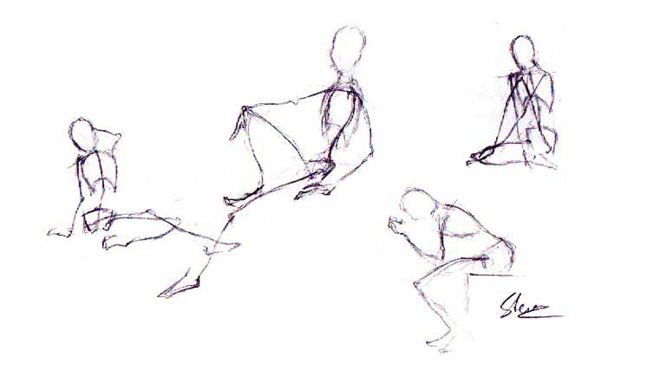
Assignment 2 Grading Criteria | Maximum Points
Accuracy and proportion of the forms and presentation. | 8
Completeness of the assignment-all elements correctly depicted. | 8
Clean, well crafted, and technically sound work. | 8
Participated in discussion with class, feedback and comments. | 4
Total: | 28
For assistance with any problems you may have when completing this assignment—OR—to offer your assistance to classmates, please use the Problems and Solutions Discussion area located through the left side navigation link.

Assignment 3: The 4-Part Figure and Gesture Drawing II
By Saturday, August 9, 2008 create a total of 5 full-length self-portraits using yourself as a live model.
- First, draw three self-portraits going from Steps 1-3 of the Four-Step Drawing Process. Draw one in a standing, one in a seated and one in a reclining pose. Spend approximately 15-20 minutes per drawing. Photograph or scan your drawing after each step. Pick the two best drawings from the three.
- Draw two new self-portraits going from steps 1-4. Draw for as long as it takes for you to feel that it is a complete, fully rendered drawing (not a sketch), taking at least 25-30 minutes. Photograph or scan your drawing after each step. Pick the best one of the two.
- Post at least two drawings showing Steps 1-3 and at least one drawing showing steps 1-4 to the Discussion Area. Using a large canvas in Photoshop arrange all of the steps in one file, so that everyone can see your step by step process.
Review and critique the work of at least two other students by the end of the week.
You may draw yourself nude, but this is not a requirement. If drawing yourself clothed, please take measures to reveal as much of the body as you feel comfortable by choosing form-fitting clothing and removing shoes, socks, gloves and hats.
This assignment must be completed by hand. Using the computer to complete this assignment will result in loss of points. Submit your responses to the appropriate Discussion Area.
Example:
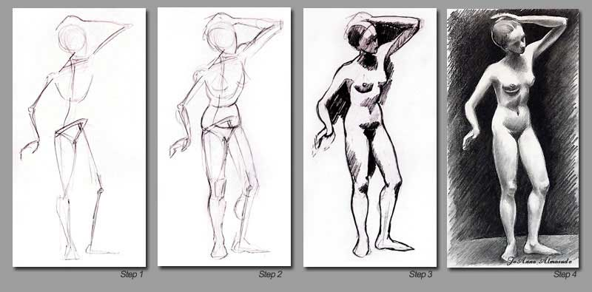
Assignment 3 Grading Criteria | Maximum Points
Balance, scale and proportion, sketch and value, and overall unity of elements. | 4
Clean, well crafted, and technically sound work. | 4
Contour and tone. | 4
Completeness of assignment. | 4
Participation in discussion with class, feedback and comments. | 4
Total: | 20
For assistance with any problems you may have when completing this assignment—OR—to offer your assistance to classmates, please use the Problems and Solutions Discussion area located through the left side navigation link.

